Location: Jingjiang (靖江)，Jiangsu Province (江苏省). Jingjiang is situated at the lower reaches of the Yangtze River. Owing to its superior geographic location, the city is within two-hour driving zone to major cities like Nanjing, Taizhou, and Changzhou in Jiangsu Province.

About us: Huaide College is an independent school affiliated to Changzhou University. Foreign Languages Department is one of the eight departments the college has. Number of English majored students is about 80 for each grade. And number of registered students (age from 17-20) at present is 5970, plus 2000 more are expected in the following autumn semester, 2016.

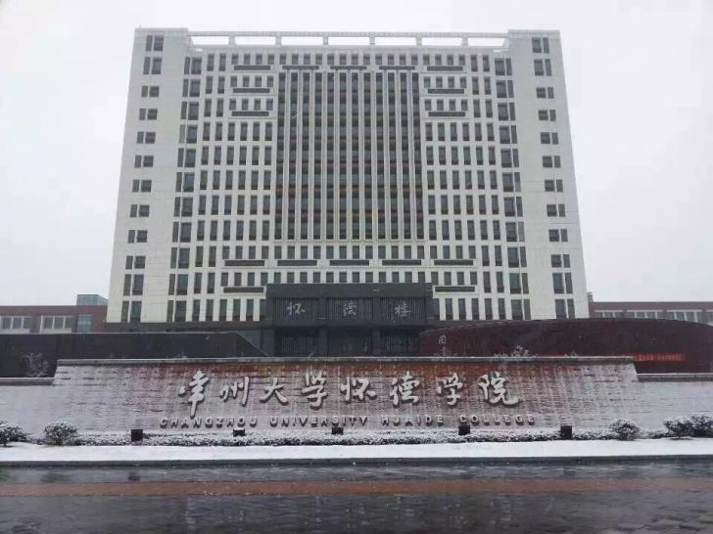

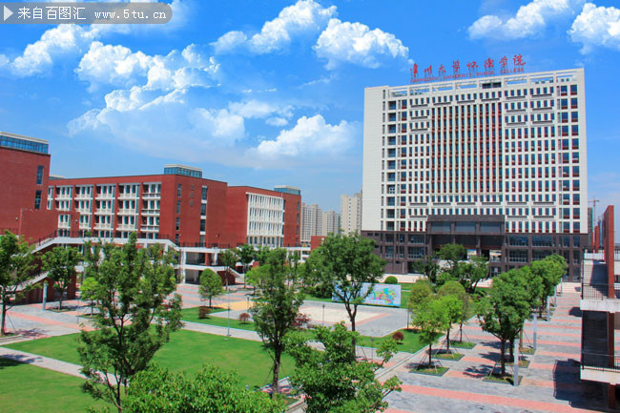

*Campus view*

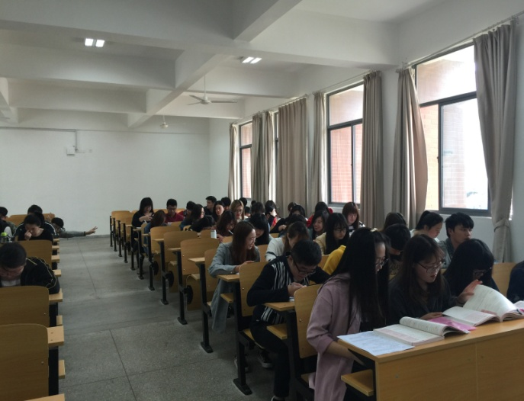

*Students*

Job description: **TWO** native English teachers are keenly needed for the general courses focus on language training. The foreign teachers will need to work four days a week for 16 classes (45 mins each). List of courses are as follows:

1. English majors / None English majors – Oral English;
2. English majors – English Writing;
3. English majors – A Brief Introduction to British and American Culture;
4. *Not Compulsory: Optional classes or lectures.*

Requirements: We are looking for native speakers who have either bachelor degrees plus some previous teaching experience OR English majored master degrees.

Contract & Payment: At least one year contract starts from 1st Sep., 2016.

8,000-9,000 Yuan/ Month.

Benefits:

1. Free apartment (65 – 80 m2) Wi-Fi; Free gas, water, and electricity; Complete facilities, bag check;
2. Free round-way flight ticket each year;
3. Free shuttle bus from Jingjiang to Changzhou everyday (except Sat.);
4. Extra pays for lectures or vocational school teaching;
5. Two college canteens on campus with Chinese cuisines.

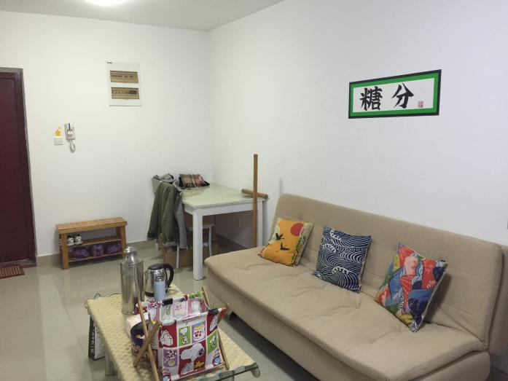*Teacher’s apartment*

For further information please visit our college website: <http://hdc.cczu.edu.cn/>

Resumes are welcome to be sent to:

Chenwei Ma

International Office, Huaide College, Changzhou University

Tel: (+86) 150-6220-0829

Email: [cherry1439@163.com](mailto:cherry1439@163.com)