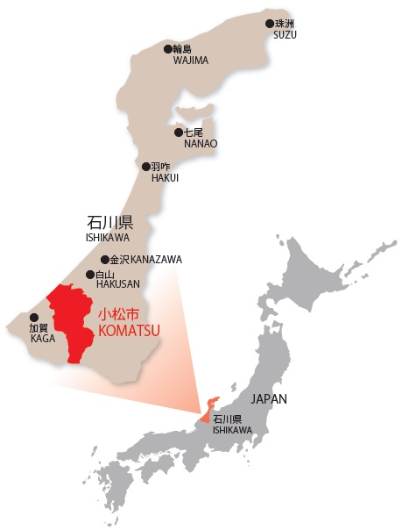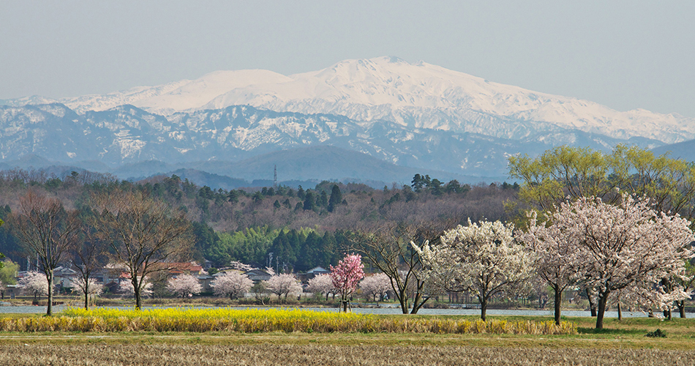

Komatsu University was founded in 2018. It benefits from the copious natural assets of the area spanning from Mt. Hakusan to the Sea of Japan, and exploits the heritage of a city of industry, culture, health, education and international understanding.

Tentative Itinerary

May 21

Arrival and Welcome Party

May 22, 25, 26, 28, and 29

* Classes on Japanese Language, Society, and Political Economy (given in English or Chinese)
* Joint Activities with Komatsu University Students
* Cultural Experience in Komatsu

May 23-24

Cultural Program in Farmers’ House

May 27

One-day sightseeing in Kamazawa

May 29 Evening

Farewell Party

May 30

End of the Program

**Komatsu Intercultural Studies Programme**

**Komatsu University, Ishikawa, Japan**

**May 21-30, 2020**