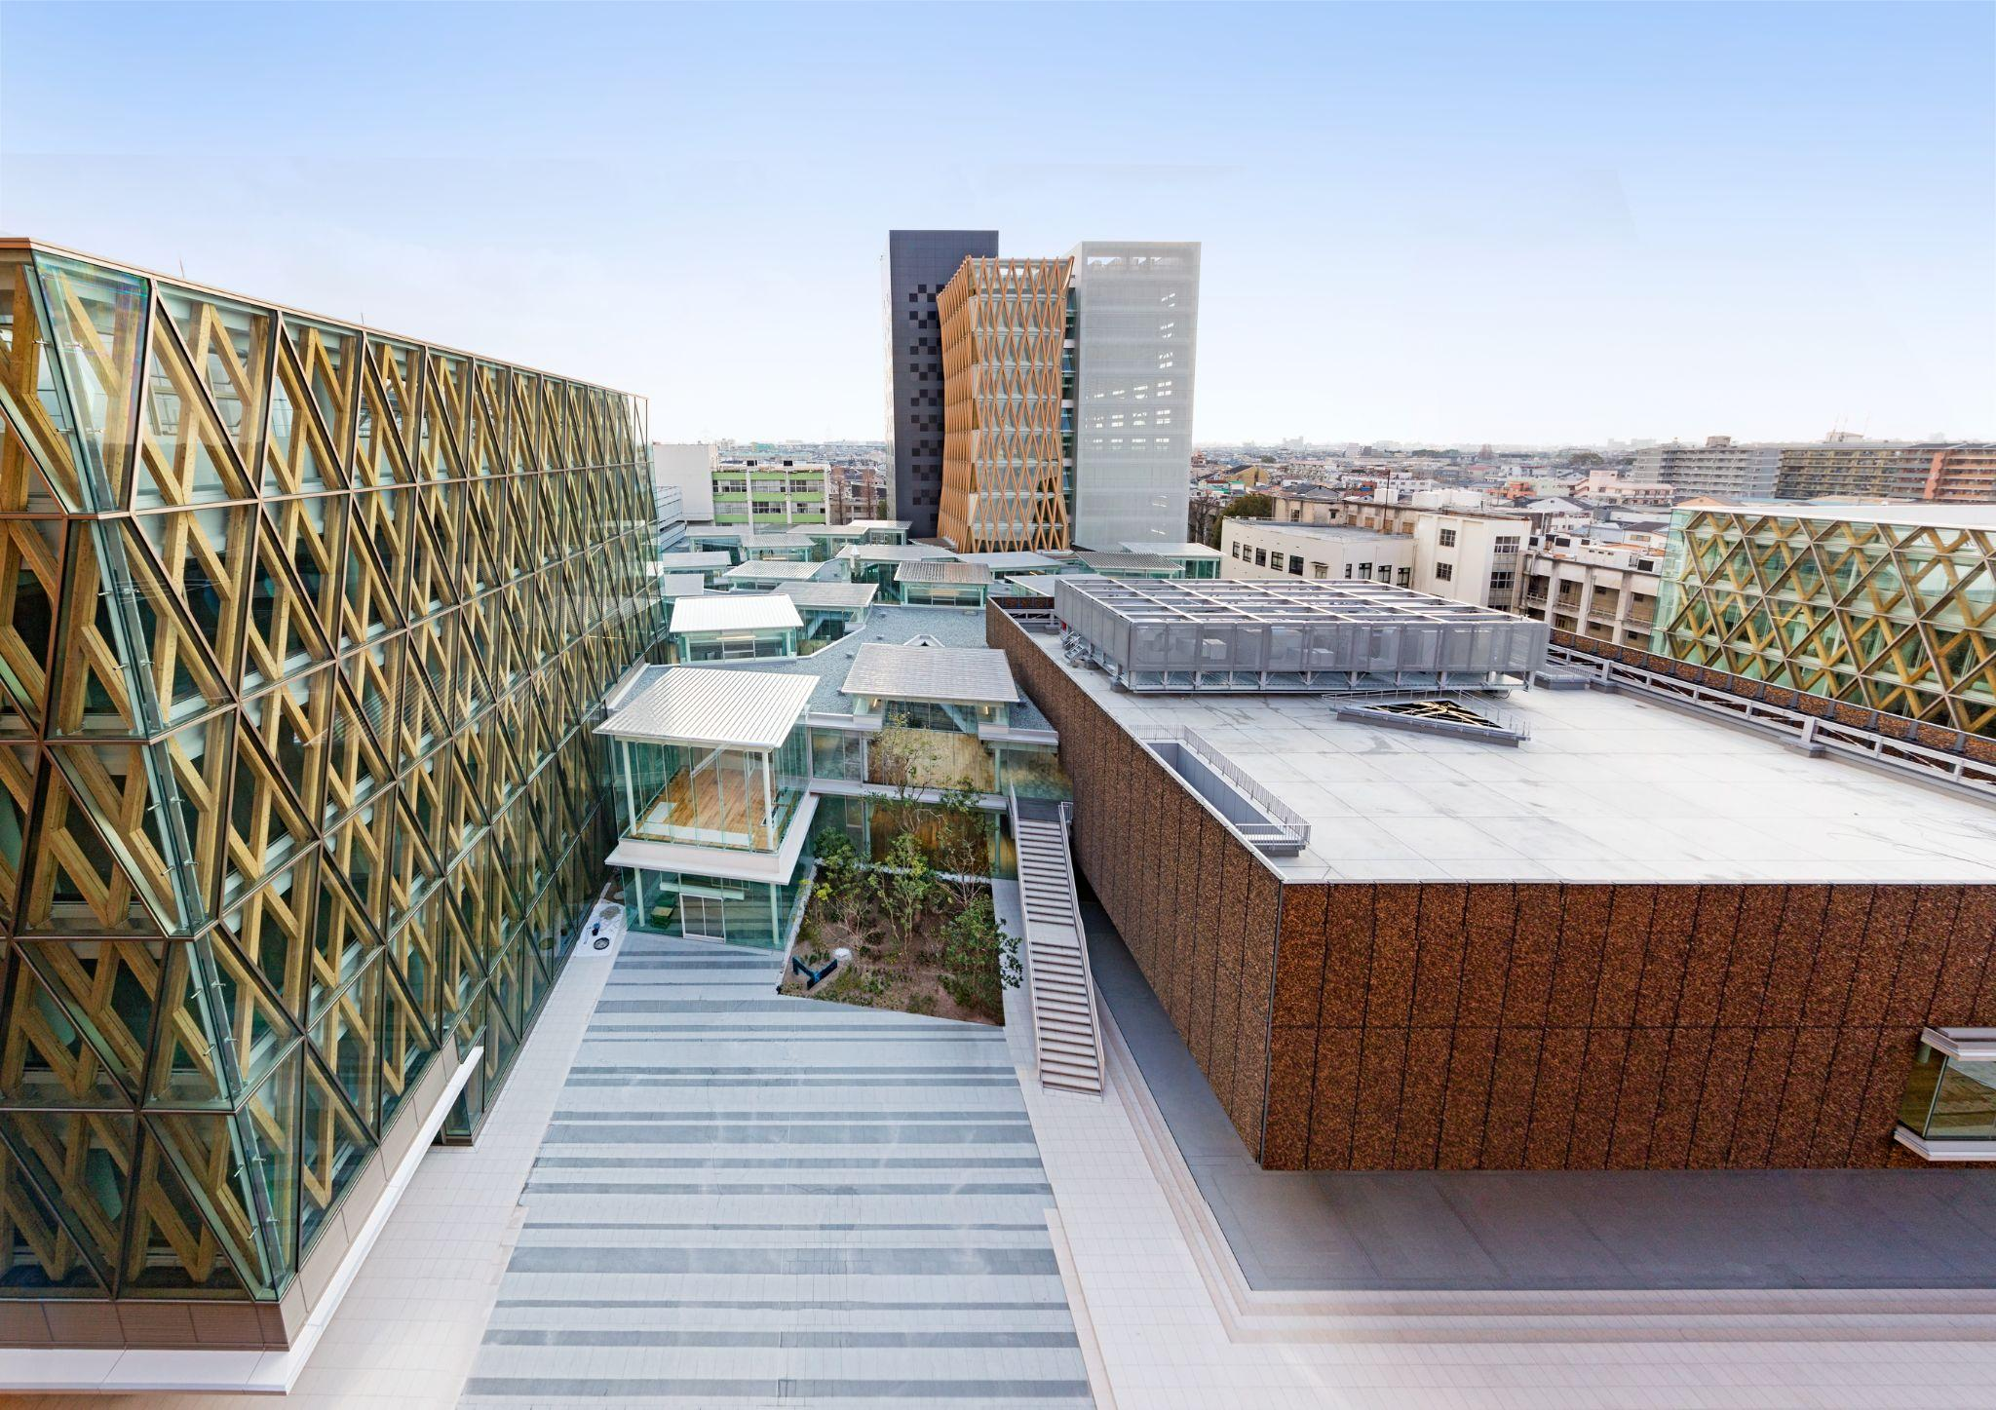

● GENERAL INFORMATION

Name of Institution | Kindai University
Official Address | 3-4-1 Kowakae, Higashiosaka-shi, Osaka 577-8502 |  | Region | Osaka, Japan
Type (Public or Private) | Private | President | MATSUMURA Itaru
Year Founded | 1925 | Website | https://www.kindai.ac.jp/english/
Overview | Kindai University was founded in 1925. Now one of Japan’s largest universities, it has six campuses in western Japan and boasts research facilities across the nation - from Hokkaido in the north to Kagoshima in the south. Currently, Kindai University comprises 15 faculties with 49 departments, 11 graduate schools and 1 transdisciplinary graduate school, 18 research facilities, two junior colleges, 18 associated primary and secondary schools, and two teaching hospitals. The university has over 30,000 students and more than 550,000 alumni.
Campuses | Higashiosaka (Main Campus)*, Osaka-Sayama, Nara, Wakayama, Hiroshima, Fukuoka  *Only Higashiosaka Campus accepts exchange students. Please refer to the faculty list to confirm the study fields that are available for exchange students.
International Relations Office | Name | Global Education Center
International Relations Office | E-mail | isc@itp.kindai.ac.jp | Tel | +81-6-4307-3081
Contact Person | Inbound (to Kindai) |  | Mr. KAMASAKA Togo
Contact Person | Outbound (from Kindai) |  | Mr. LIU Yutong
Contact Person | Agreement |  | Ms. KASATANI Hideka
● ACADEMICS
Undergraduate Programs | Faculty of Law（J）**  Faculty of Economics（J）**  Faculty of Business Administration（E/J）  Faculty of Science and Engineering（J）**  Faculty of Architecture（J）**  Faculty of Pharmacy  Faculty of Literature, Arts and Cultural Studies（E/J）  Faculty of Applied Sociology（J）**  Faculty of International Studies（E/J）  Faculty of Informatics（J）**  Faculty of Agriculture  Faculty of Medicine  Faculty of Biology-Oriented Science and Technology  Faculty of Engineering  Faculty of Humanity-Oriented Science and Engineering
Graduate Programs** | Graduate School of Law（J）**  Graduate School of Commerce  Graduate School of Economics（J）**  Graduate School of Science and Engineering（J）**  Graduate School of Pharmacy  Graduate School of Interdisciplinary Human Studies（J）**  Graduate School of Agriculture  Graduate School of Medical Sciences  Graduate School of Biology-Oriented Science and Technology  Graduate School of Systems Engineering  Graduate School of Humanity-Oriented Science and Engineering  Transdisciplinary Graduate School of Innovation and Entrepreneurship
*Faculties that open courses for exchange students are shown in bold letters.
(E= courses in English are available, J = courses in Japanese are available)
**Permission is required to take the course and may not be available.
● STUDENT AND STAFF STATISTICS
No. of Staff(as of May 2022)  *incl. affiliated schools etc. | Academic (Full-time) | 2,268
No. of Staff(as of May 2022)  *incl. affiliated schools etc. | Academic(Part time) | 3,578
No. of Staff(as of May 2022)  *incl. affiliated schools etc. | Administrative | 3,576

No. of Students (as of May 2022) | Total | International
Undergraduate | 34,156 | 434
Postgraduate | 1,288 | 56

● UNIVERSITY RANKINGS

World University Rankings 2023 | 801-1000
CWTS Leiden Ranking 2022 | 841
URAP World University Ranking 2022-2023 | 920

● PARTNER INSTITUTIONS (As of April 2023)

No. of Partner Institutions | 272
No. of Countries | 52
For the latest information, please visit https://www.kindai.ac.jp/english/about/sisterschools.html
● EXCHANGE PROGRAM

Kindai University provides 2 student exchange programs:
Program A is to offer courses in English and Program B is in Japanese.
*We do not contact students directly until we receive an official nomination from the partners.
If there are any questions, please make sure that inquiries are made by the person in charge of the exchange program.
 | Program A |  | Program B
Language of Instruction | English |  | Japanese
Calender | Spring Semester  (April) | Nomination Deadline：End of September  Application Deadline：End of October  Result Announcement：End of November - Early December  Arrival：End of March  Semester Starts：April 1  Semester Ends：Early August (Examination：End of July - Early August)  Transcript Issuance：End of August (Official transcript is sent by email. )
Calender | Fall Semester  (September) | Nomination Deadline：End of February  Application Deadline：End of March  Result Announcement：End of April - Early May  Arrival：Early September  Semester Starts：Middle of September  Semester Ends：Ealy February (Examination：End of January - Early February)  Transcript Issuance：End of February (Official transcript is sent by email. )
Program Length | - 6 months (1 semester)  - 1 year (2 semesters)
Eligibility | - Those who do not have Japanese nationality  - Those who will not graduate or complete their degree program at their home institution before the end of the Kindai University exchange program  ＊Please note that graduate students can participate in our program but can register for only  undergraduate level courses.  ＊Even if the student will graduate from their home university during the exchange period, we can accept the student who are to go on to postgraduate course of the home university.  In this case, the submission of a letter of admission to the graduate school is required.  ＊Exchange students cannot participate in Kindai University club activities(ex: Baseball, Kendo, Sado etc.).
Course Information | Students who choose "Program A" can take classes from the list A.  【List A】  *Exchange students must take more than 7 courses per semester |  | Students who choose "Program B" can take classes from the list B.  【List B】  *Exchange students must take more than 7 courses per semester
Academic Requirement | More than 78 in the 100 Point Scale in the "C.G.P.A. Conversion Table"  【C.G.P.A. Conversion Table】  *If the student does not have more than 78 in the 100 Point Scale, submission of the following document upon application will be required.  【Letter of Academic Achievement】
Language Requirement | TOEFL iBT 61, IELTS 6.0, CEFR B2, Duolingo English Test (DET) 100 or equivalent  *Students who cannot submit any English test score must submit the following document upon application.  *Those whose native language is English do not need to submit the document.  【Letter of Language Competence】 |  | JLPT N2, N1
Accommodation | All exchange students are required to stay at accommodations that Kindai University arranges.  Before arriving, students must pay full rent for one semester. One semester rent will be 240,000~300,000 yen (Payment method is by credit card only).  Further information will be announced to applicants.
Estimated Living Expenses  (per month) | Housing : 40,000~50,000yen  Food : 30,000yen  Personal Expenses : 20,000yen  -----------------------  Total : 90,000~100,000yen
Visa | All exchange students are required to go through visa issuance procedures at the Japanese embassy or consulate general in the country where students are staying.  Instructions on how to apply and the following necessary documents will be sent by email after the submission of application.  - Certificate of Eligibility (COE)  - Kindai University Letter of Acceptance
Insurance | - National Health Insurance (kokumin kenko hoken)  Foreigners who have received a residence card are required to join the National Health Insurance system. You will have to pay monthly fees, but with this insurance you only need to pay 30% of your medical bills. This insurance is valid throughout Japan, so make sure to bring the card with you on domestic trips.The insurance fee will be about 20,000 ~ 30,000 yen for one semester.  - Insurance Support Required by Kindai University  Comprehensive Student Insurance provides comprehensive coverage for 24 hours and 365 days, including not only accidents occurring during school life, but also private accidents and medical expenses. All exchange students are required to take out this insurance. The insurance premiums are included in the housing payment amount.  Also, all exchange students have access to a 24 hours medical consultation service.  (Getting overseas travel insurance is recommended to secure the travel abroad. Please complete the purchasing procedure of the travel insurance by yourself.)

〈Supports〉
・Japanese Language Courses
There are Japanese Language Courses (ES Courses, Tokurei Courses) which are designed to help exchange students improve their Japanese language skills.
These courses provide credits.
Japanese placement test will be held after students’ arrival, and they will be graded from level 1 (beginner) to 5 (advanced).

・Language Partner Program
All exchange students will get a student volunteer named Language Partner to help with the life in Kindai.

・Orientation Week
The orientation activities are held a week before the academic year begins.
All exchange students are required to attend the orientation activities.

● KINDAI SHORT-TERM JAPANESE PROGRAM
For the latest information, please visit https://www.kindai.ac.jp/english/study-at-kindai/short-term/

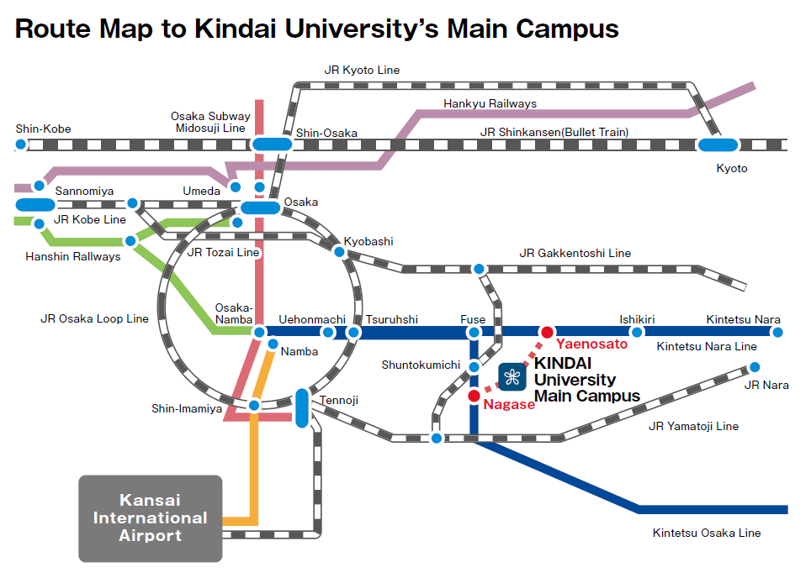
● ACCESS

